Name: Edmond Agyemang

Date: Dec 10, 2024

CIS 344 Final Project Report: restaurant_reservations

Beginning with the MySQL component of the project, I established the

‘restaurant_reservations’ database and constructed three tables named ‘customers’,

‘diningpreferences’, and ‘reservations’. Each table was populated with essential attributes and corresponding foreign keys. Subsequently, I inserted test entries into the all the tables to verify its initialization and ensure its visibility, as demonstrated here.

SELECT * From ‘Customers’

SELECT * From ‘diningPreferences’

SELECT * From ‘reservations’

Next, I have created two stored procedures to ‘fin the reservation’ and ‘add a special customer request. findReservations procedure uses the existing customer id to find the reservation and addSpecialRequest procedure uses the existing reservation for the same.

The next stored procedure is addReservation procedure. This procedure checks if the customer id exists or not. If the customer id is not present, the new customer id created and then the reservation is made.

**PHP**: I started off by modifying the restaurant_reservations.php file with the appropriate MySQL Credentials: To first communicate with MySQL, I used the same port number database that's in MySQL so PHP can retrieve the information.

Next, I added methods in php to do various tasks such as adding and viewing reservations, Adding customer. Each method in this portion of the python code is similar except for changing the “query” portion to each method's respective statements that correspond to the statements in MySQL.

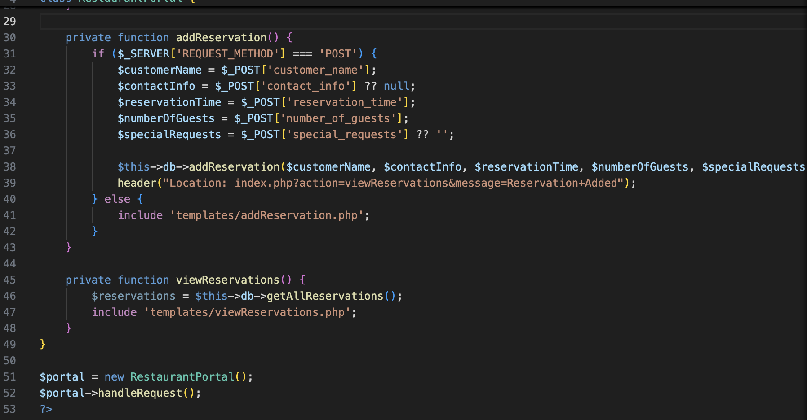

Some of the additional functions I implemented are getCustomerPreference, addSpecialRequest, findReservation, and deleteReservation.

Now in the restuarantServer.php file

Mainly I called the methods from the restuarantDatabase.php and made sure it was visible on the local host web page. For adding reservation, in do_POST I initialize the variables from the reservation table and then call the method to add a new reservation from the database file.

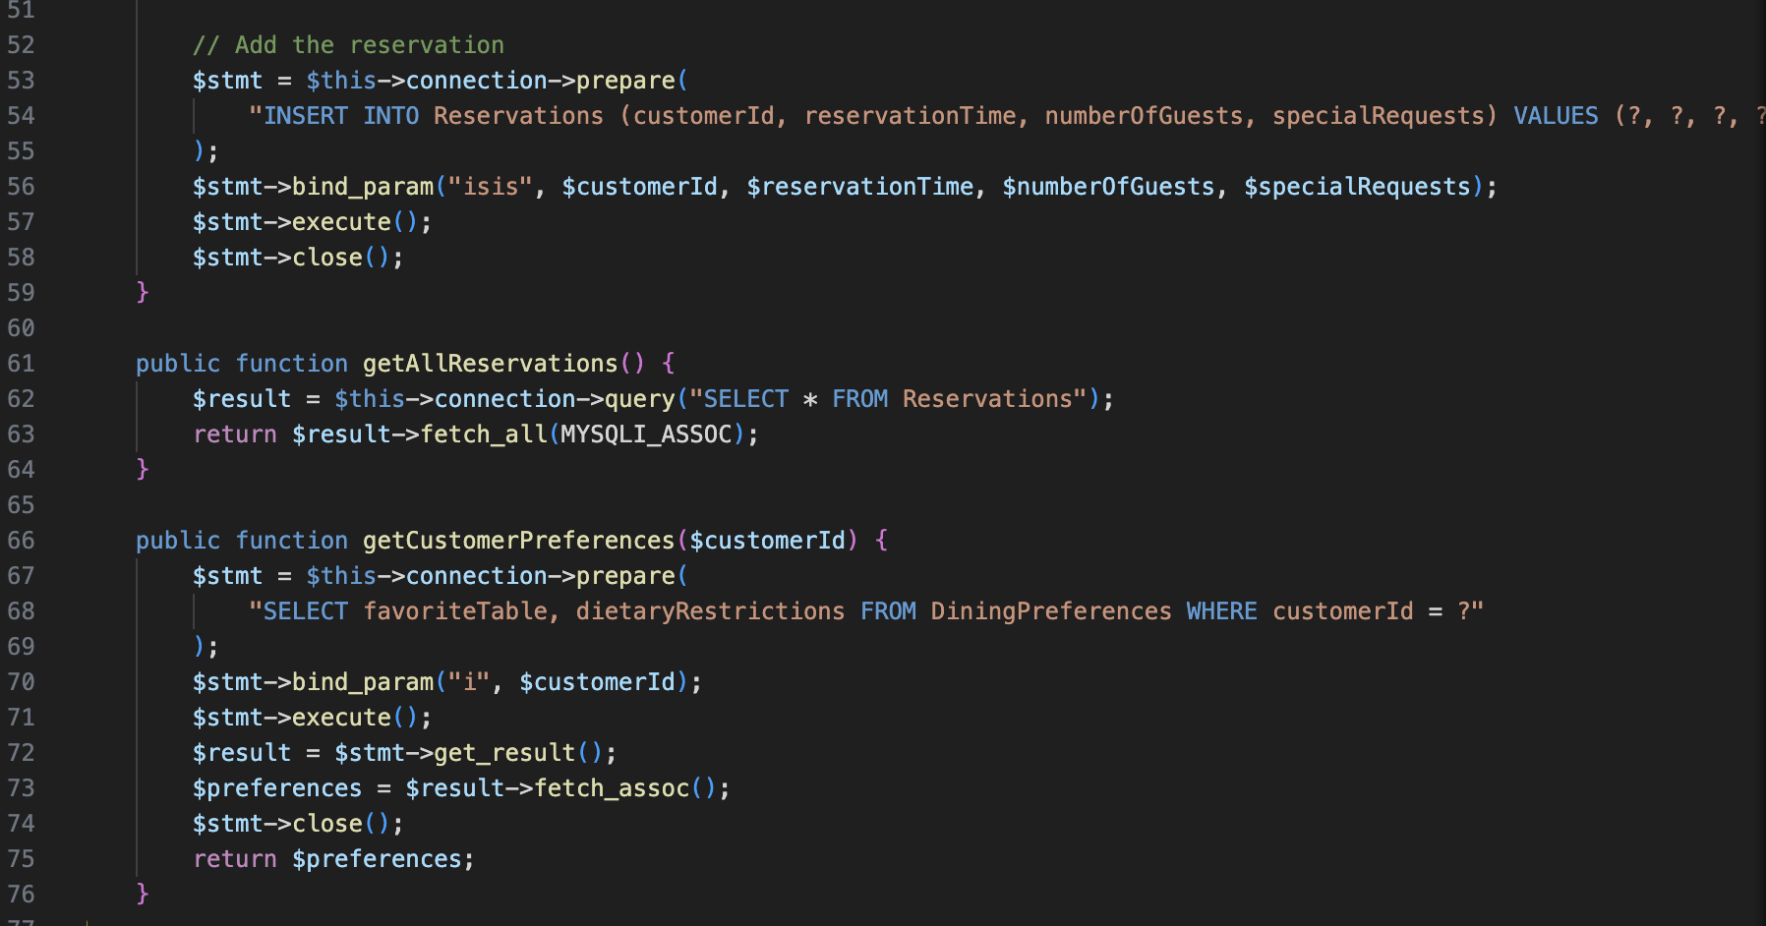

Similarly, I have called other functions as well in the server file as per the requirements of the project.

Other things I added were some validation inputs to make sure that a user actually inserts data into the forms when adding a reservation and deleting a reservation.

If they do not enter information they are prompted to do it.

I also made sure to place the menu navigation links on all the pages throughout the website to make the view uniform and pleasant.

I also added some comments to guide the user on how to type in their reservation.

See Screenshots of the website in full function below.

ADD RESERVATIONS



VIEW TO SEE IF RESERVATION ADDED

DELETE RESERVATION BY ID



VIEW ALL RESERVATIONS TO SEE IF RESERVATION DELETED